String Functions

# Using single quotes
str1 = 'Hello Python'
print(str1)

# Using double quotes
str2 = "Hello Python"
print(str2)

# Using triple quotes
str3 = '''Triple quotes are generally used
for representing multiline strings
or docstrings.'''
print(str3)

Python String Methods with Examples and Outputs

1. capitalize() - Converts the first character to upper case
txt = "hello, and welcome to my world."
x = txt.capitalize()
print(x) # Output: Hello, and welcome to my world.

# Example 2:
txt = "36 is my age."
x = txt.capitalize()
print(x) # Output: 36 is my age.

2. casefold() - Converts string into lower case
txt = "Hello, And Welcome To My World!"
x = txt.casefold()
print(x) # Output: hello, and welcome to my world!

3. center() - Returns a centered string
txt = "banana"

x = txt.center(20)
print(x) # Output: ' banana '

4. count() - Returns the number of times a specified value occurs in a string
txt = "I love apples, apple are my favorite fruit"
x = txt.count("apple")
print(x) # Output: 2

x = txt.count("apple", 10, 24)
print(x) # Output: 1

5. encode() - Returns an encoded version of the string
txt = "My name is Ståle"
x = txt.encode()
print(x) # Output: b'My name is St\xc3\xa5le'

6. endswith() - Returns true if the string ends with the specified value
txt = "Hello, welcome to my world."
x = txt.endswith(".")
print(x) # Output: True

x = txt.endswith("my world.")
print(x) # Output: True

x = txt.endswith("my world.", 5, 11)
print(x) # Output: False

7. expandtabs() - Sets the tab size of the string
txt = "H\te\tl\tl\to"
x = txt.expandtabs(2)
print(x) # Output: H e l l o

print(txt) # Output: H e l l o
print(txt.expandtabs()) # Output: H e l l o
print(txt.expandtabs(2)) # Output: H e l l o
print(txt.expandtabs(4)) # Output: H e l l o
print(txt.expandtabs(10)) # Output: H e l l o

8. find() - Searches the string for a specified value and returns the position
txt = "Hello, welcome to my world."

x = txt.find("welcome")
print(x) # Output: 7

x = txt.find("e")
print(x) # Output: 1

x = txt.find("e", 5, 10)
print(x) # Output: 8

print(txt.find("q")) # Output: -1
# print(txt.index("q")) # Raises ValueError

9. format() - Formats specified values in a string
txt = "For only {price:.2f} dollars!"
print(txt.format(price = 49)) # Output: For only 49.00 dollars!

10. index() - Same as find() but raises an error if not found
txt = "Hello, welcome to my world."
x = txt.index("welcome")
print(x) # Output: 7

x = txt.index("e")
print(x) # Output: 1

x = txt.index("e", 5, 10)
print(x) # Output: 8

11. isalnum() - Returns True if all characters are alphanumeric
txt = "Company12"
x = txt.isalnum()
print(x) # Output: True

txt = "Company 12"
x = txt.isalnum()

print(x) # Output: False

12. isalpha() - Returns True if all characters are in the alphabet
txt = "CompanyX"
x = txt.isalpha()
print(x) # Output: True

txt = "Company10"
x = txt.isalpha()
print(x) # Output: False

13. isupper() - Returns True if all characters in the string are uppercase
txt = "THIS IS NOW!"
x = txt.isupper()
print(x) # Output: True

14. join() - Joins the elements of an iterable
myTuple = ("John", "Peter", "Vicky")
x = "#".join(myTuple)
print(x) # Output: John#Peter#Vicky

15. lower() - Converts a string into lower case
txt = "Hello my FRIENDS"
x = txt.lower()
print(x) # Output: hello my friends

16. lstrip() - Returns a left trim version of the string
txt = " banana "
x = txt.lstrip()
print("of all fruits", x, "is my favorite")
# Output: of all fruits banana is my favorite

txt = ",,,,,ssaaww.....banana"
x = txt.lstrip(",.asw")
print(x) # Output: banana

17. replace() - Replaces a string with another string
txt = "I like bananas"
x = txt.replace("bananas", "apples")
print(x) # Output: I like apples

txt = "one one was a race horse, two two was one too."
x = txt.replace("one", "three")
print(x) # Output: three three was a race horse, two two was three too.

18. split() - Splits the string into a list
txt = "welcome to the jungle"
x = txt.split()
print(x) # Output: ['welcome', 'to', 'the', 'jungle']

txt = "hello, my name is Peter, I am 26 years old"
x = txt.split(", ")
print(x) # Output: ['hello', 'my name is Peter', 'I am 26 years old']

txt = "apple#banana#cherry#orange"
x = txt.split("#")
print(x) # Output: ['apple', 'banana', 'cherry', 'orange']

19. splitlines() - Splits the string at line breaks
txt = "Thank you for the music\nWelcome to the jungle"
x = txt.splitlines()
print(x) # Output: ['Thank you for the music', 'Welcome to the jungle']

x = txt.splitlines(True)
print(x) # Output: ['Thank you for the music\n', 'Welcome to the jungle']

20. upper() - Converts a string into upper case
txt = "Hello my friends"
x = txt.upper()
print(x) # Output: HELLO MY FRIENDS

Built-in Math Functions
min(), max() - Find minimum or maximum value
x = min(5, 10, 25)
y = max(5, 10, 25)
print(x) # Output: 5
print(y) # Output: 25
abs() - Returns the absolute (positive) value
x = abs(-7.25)
print(x) # Output: 7.25
pow(x, y) - Returns the value of x to the power of y (x^y)
x = pow(4, 3)
print(x) # Output: 64

The Math Module
To use more advanced math operations, Python provides the built-in math module:
math.sqrt() - Returns the square root of a number
import math
x = math.sqrt(64)
print(x) # Output: 8.0
math.ceil() and math.floor() - Round a number up or down
import math
x = math.ceil(1.4)

y = math.floor(1.4)
print(x) # Output: 2
print(y) # Output: 1
math.pi - Returns the value of PI
import math
x = math.pi
print(x) # Output: 3.141592653589793

List

Creating Lists and Accessing Elements
list1 = ["yuva", "sakthi", "academy"]
print(list1) # Output: ['yuva', 'sakthi', 'academy']

print(len(list1)) # Output: 3

list2 = [1, 5, 7, 9, 3]
list3 = [True, False, False]

list1 = ["abc", 34, True, 40, "male"]
print(type(list1)) # Output: <class 'list'>

list1 = list(("apple", "mango", "orange"))
print(list1) # Output: ['apple', 'mango', 'orange']

print(list1[1]) # Output: mango
print(list1[-1]) # Output: orange
print(list1[2:4]) # Output: ['orange'] (if 4th item exists)
print(list1[:3]) # Output: ['apple', 'mango', 'orange']
print(list1[1:]) # Output: ['mango', 'orange']
print(list1[-4:-1]) # Output depends on list size
Check Existence and Modify List Items
if "yuva" in list1:
print("Yes, 'yuva' is in the list")

list1[1] = "systems" # Replace element at index 1
list1[1:3] = ["kalpana", "sakthi"] # Replace a range
list1[1:2] = ["kalpana", "sakthi"] # Replace one item with two
list1[1:3] = ["sakth"] # Replace two items with one
Add Items
list1.insert(2, "kalpana") # Insert at index 2
list1.append("sakth") # Add at the end

list2.extend(list3) # Add list3 to list2
Remove Items
list1.remove("sakthi") # Remove by value

list1.pop(1) # Remove by index
list1.pop() # Remove last item
del list1[0] # Delete by index
del list1 # Delete entire list
list1.clear() # Clear all items from list
Loop Through Lists
for x in list1:
print(x)
for i in range(len(list1)):
print(list1[i])
i = 0
while i < len(list1):
print(list1[i])
i += 1

[print(x) for x in list1] # List comprehension loop

List Comprehension
fruits = ["apple", "banana", "cherry", "kiwi", "mango"]
newlist = []
for x in fruits:
if "a" in x:
newlist.append(x)
print(newlist) # Output: ['apple', 'banana', 'mango']
newlist = [x for x in fruits if "a" in x] # Same as above using list comprehension
newlist = [x for x in fruits if x != "apple"] # Exclude 'apple'
Sorting and Reversing Lists
list1.sort() # Sort alphabetically
list1.sort(reverse=True) # Sort in descending order
list1.sort(key=str.lower) # Case-insensitive sort
list1.reverse() # Reverse list order
Copying and Joining Lists
list2 = list1.copy()
list2 = list(list1)
list3 = list1 + list2
for x in list2:
list1.append(x)

list1.extend(list2) # Add list2 items to list1

Python Tuple Basics and Operations
Definition:
Tuples are ordered collections that are immutable (unchangeable) once defined.
1. Creating and Accessing Tuples
tuple1 = ("apple", "banana", "cherry")
print(tuple1)
print(len(tuple1))
2. Single Element Tuple
tuple1 = ("apple",)
print(type(tuple1))
tuple1 = ("apple") # Not a tuple
print(type(tuple1)) # Output: <class 'str'>
3. Tuple with Mixed Data Types
tuple2 = (1, 5, 7, 9, 3)
tuple3 = (True, False, False)
4. Tuple Constructor
tuple1 = tuple(("apple", "banana", "cherry"))
print(tuple1)
5. Tuple Indexing and Slicing
tuple1 = ("apple", "banana", "cherry")
print(tuple1[1])
print(tuple1[-1])
tuple1 = ("apple", "banana", "cherry", "orange", "kiwi", "melon", "mango")
print(tuple1[2:5])
print(tuple1[:4])
print(tuple1[2:])

print(tuple1[-4:-1])
6. Check for Item
if "apple" in tuple1:
print("Yes, 'apple' is in the fruits tuple")

7. Change Tuple Values (via list conversion)
x = ("apple", "banana", "cherry")
y = list(x)
y[1] = "kiwi"
x = tuple(y)
print(x)
8. Add/Remove Items by Conversion
thistuple = ("apple", "banana", "cherry")
y = list(thistuple)
y.append("orange")
thistuple = tuple(y)
9. Delete Tuple
thistuple = ("apple", "banana", "cherry")
del thistuple
10. Unpacking a Tuple
fruits = ("apple", "banana", "cherry")
(green, yellow, red) = fruits
print(green)
print(yellow)
print(red)

11. Using Asterisk for Variable Capture
fruits = (“apple”, “mango”, “papaya”, “pineapple”, “cherry”)
(green, *tropic, red) = fruits
print(green)
print(tropic)
print(red)
12. Loop Through Tuple
for x in tuple1:
print(x)
for I in range(len(tuple1)):
print(tuple1[i])
I = 0
while I < len(tuple1):
print(tuple1[i])
I += 1
13. Join and Multiply Tuples
tuple1 = (“a”, “b” , “c”)
tuple2 = (1, 2, 3)
tuple3 = tuple1 + tuple2
print(tuple3)

fruits = (“apple”, “banana”, “cherry”)
mytuple = fruits * 2
print(mytuple)

Python Set Basics and Operations

Definition:
A set is a collection that is unordered, unindexed, and contains no duplicate elements. Sets are defined using curly braces {}.
1. Creating and Accessing Sets
thisset = {"apple", "banana", "cherry"}
print(thisset)
for x in thisset:
print(x)
print("banana" in thisset) # Membership test
2. Adding and Updating Items
thisset.add("orange")
thisset.update(["orange", "mango", "grapes"])
print(thisset)
3. Removing Items
thisset.remove("banana")
thisset.discard("banana")
x = thisset.pop() # Removes a random item
thisset.clear()
del thisset
4. Set Operations
set1 = {"a", "b", "c"}
set2 = {1, 2, 3}
set3 = set1.union(set2)
set1.update(set2)
print(set1)

5. Set Comparisons
x = {“apple”, “banana”, “cherry”}
y = {“google”, “icrosoft”, “apple”}
z = x.intersection(y)
print(z)

result = x.intersection({“banana”, “cherry”}, {“cherry”})
print(result)

z = x.difference(y)
print(z)

z = x.isdisjoint({“facebook”, “icrosoft”})
print(z)

z = {“a”, “b”, “c”}.issubset({“a”, “b”, “c”, “d”})
print(z)

z = {“a”, “b”, “c”, “d”}.issuperset({“b”, “c”})
print(z)

z = x.symmetric_difference(y)
print(z)

Python Dictionary Basics and Operations
Definition:
A dictionary is a collection that is ordered* (as of Python 3.7), changeable, and does not allow duplicates. Dictionaries are written with curly brackets and have keys and values.
1. Creating and Accessing a Dictionary
dict1 = {
"brand": "Ford",
"model": "Mustang",
"year": 1964
}
print(dict1) # Output: {'brand': 'Ford', 'model': 'Mustang', 'year': 1964}
print(dict1["brand"]) # Output: Ford
print(len(dict1)) # Output: 3
2. Dictionary with Multiple Types of Values
dict1 = {
"brand": "Ford",
"model": "Mustang",
"year": 1964,
"colors": ["red", "white", "blue"]
}
print(type(dict1)) # Output: <class 'dict'>
3. Accessing and Modifying Dictionary Data
x = dict1.get("model")
x = dict1.keys()
dict1["color"] = "white"
print(dict1)

4. Dictionary Methods
print(dict1.values())
print(dict1.items())
if "model" in dict1:
print("Yes, 'model' is one of the keys")
dict1["year"] = 2018
5. Updating, Removing, and Copying
dict1.update({"year": 2020})
dict1["color"] = "red"
dict1.pop("model")
dict1.popitem()
del dict1["year"]
dict1.clear()
dict1 = dict1.copy()
mydict = dict(dict1)
6. Looping Through Dictionary
for x in dict1:
print(x)
for x in dict1:
print(dict1[x])
for x in dict1.values():
print(x)
for x in dict1.keys():
print(x)
for x, y in dict1.items():
print(x, y)

Exercise 1: Reverse a given list in Python
aLsit = [100, 200, 300, 400, 500]
Expected output:
[500, 400, 300, 200, 100]

Exercise 2: Concatenate two lists index-wise
Given:
list1 = ["M", "na", "i", "Ke"]
list2 = ["y", "me", "s", "lly"]
Expected output:
['My', 'name', 'is', 'Kelly']

Exercise 3: Given a Python list of numbers. Turn every item of a list into its square
Given:
aList = [1, 2, 3, 4, 5, 6, 7]
Expected output:
[1, 4, 9, 16, 25, 36, 49]

Exercise 4: Concatenate two lists in the following order
list1 = ["Hello ", "take "]
list2 = ["Dear", "Sir"]

Expected output:
['Hello Dear', 'Hello Sir', 'take Dear', 'take Sir']

Exercise 5: Given a two Python list. Iterate both lists simultaneously such that list1 should display item in original order and list2 in reverse order
Given
list1 = [10, 20, 30, 40]
list2 = [100, 200, 300, 400]
Expected output:
10 400
20 300
30 200
40 100

Exercise 6: Remove empty strings from the list of stringslist1 = ["Mike", "", "Emma", "Kelly", "", "Brad"]
Expected output:

["Mike", "Emma", "Kelly", "Brad"]

Exercise 7: Add item 7000 after 6000 in the following Python List
Given:
list1 = [10, 20, [300, 400, [5000, 6000], 500], 30, 40]

Expected output:
[10, 20, [300, 400, [5000, 6000, 7000], 500], 30, 40]

Exercise 8: Given a nested list extend it by adding the sub list ["h", "i", "j"] in such a way that it will look like the following list
Given List:
list1 = ["a", "b", ["c", ["d", "e", ["f", "g"], "k"], "l"], "m", "n"]

Sub List to be added = ["h", "i", "j"]
Expected output:
['a', 'b', ['c', ['d', 'e', ['f', 'g', 'h', 'i', 'j'], 'k'], 'l'], 'm', 'n']

Exercise 9: Given a Python list, find value 20 in the list, and if it is present, replace it with 200. Only update the first occurrence of a value

Given
list1 = [5, 10, 15, 20, 25, 50, 20]
Expected output:
list1 = [5, 10, 15, 200, 25, 50, 20]

Exercise 10: Given a Python list, remove all occurrence of 20 from the list
list1 = [5, 20, 15, 20, 25, 50, 20]

Expected output:
[5, 15, 25, 50]

Exercise 1: Below are the two lists convert it into the dictionary
keys = ['Ten', 'Twenty', 'Thirty']
values = [10, 20, 30]
Expected output:
{'Ten': 10, 'Twenty': 20, 'Thirty': 30}

Exercise 2: Merge following two Python dictionaries into one
dict1 = {'Ten': 10, 'Twenty': 20, 'Thirty': 30}
dict2 = {'Thirty': 30, 'Fourty': 40, 'Fifty': 50}
Expected output:
{'Ten': 10, 'Twenty': 20, 'Thirty': 30, 'Fourty': 40, 'Fifty': 50}

Exercise 3: Access the value of key ‘history’ from the below dict
sampleDict = {
"class":{
"student":{
"name":"Mike",
"marks":{
"physics":70,
"history":80
}
}
}
}
Expected output:
80

Exercise 4: Initialize dictionary with default values
Given
employees = ['Kelly', 'Emma', 'John']
defaults = {"designation": 'Application Developer', "salary": 8000}

Exercise 5: Create a new dictionary by extracting the following keys from a below dictionary
Given dictionary:
sampleDict = {
"name": "Kelly",
"age":25,
"salary": 8000,
"city": "New york"

}
Keys to extract
keys = ["name", "salary"]
Expected output:

{'name': 'Kelly', 'salary': 8000}

Exercise 6: Delete set of keys from a dictionary
Given:
sampleDict = {
"name": "Kelly",
"age":25,
"salary": 8000,
"city": "New york"

}
keysToRemove = ["name", "salary"]

Expected output:
{'city': 'New york', 'age': 25}

Exercise 7: Check if a value 200 exists in a dictionary
sampleDict = {'a': 100, 'b': 200, 'c': 300}
Expected output:
True

Exercise 8: Rename key city to location in the following dictionary
sampleDict = {
"name": "Kelly",
"age":25,
"salary": 8000,
"city": "New york"
}

Expected output:
{
"name": "Kelly",
"age":25,
"salary": 8000,
"location": "New york"
}

Exercise 9: Get the key of a minimum value from the following dictionary
sampleDict = {
'Physics': 82,
'Math': 65,
'history': 75
}
Expected output:

Exercise 10: Change Brad’s salary to 8500 from a given Python dictionary
sampleDict = {
'emp1': {'name': 'Jhon', 'salary': 7500},
'emp2': {'name': 'Emma', 'salary': 8000},
'emp3': {'name': 'Brad', 'salary': 6500}
}
Expected output:
sampleDict = {
'emp1': {'name': 'Jhon', 'salary': 7500},
'emp2': {'name': 'Emma', 'salary': 8000},
'emp3': {'name': 'Brad', 'salary': 8500}
}

Exercise 1: Add a list of elements to a given set
Given:
sampleSet = {"Yellow", "Orange", "Black"}
sampleList = ["Blue", "Green", "Red"]
Expected output:
Note: Set is unordered.
{'Green', 'Yellow', 'Black', 'Orange', 'Red', 'Blue'}

Exercise 2: Return a new set of identical items from a given two set
set1 = {10, 20, 30, 40, 50}
set2 = {30, 40, 50, 60, 70}

Expected output:
{40, 50, 30}

Exercise 3: Returns a new set with all items from both sets by removing duplicates
set1 = {10, 20, 30, 40, 50}
set2 = {30, 40, 50, 60, 70}
Expected output:
{70, 40, 10, 50, 20, 60, 30}

Exercise 4: Given two Python sets, update the first set with items that exist only in the first set and not in the second set.
set1 = {10, 20, 30}
set2 = {20, 40, 50}
Expected output:
set1 {10, 30}

Exercise 5: Remove items 10, 20, 30 from the following set at once
set1 = {10, 20, 30, 40, 50}
Expected output:
{40, 50}

Exercise 6: Return a set of all elements in either A or B, but not both
set1 = {10, 20, 30, 40, 50}
set2 = {30, 40, 50, 60, 70}

Expected output:
{20, 70, 10, 60}

Exercise 7: Check if two sets have any elements in common. If yes, display the common elements.
set1 = {10, 20, 30, 40, 50}
set2 = {60, 70, 80, 90, 10}

Expected output:
Two sets have items in common
{10}

Exercise 8: Update set1 by adding items from set2, except common items
set1 = {10, 20, 30, 40, 50}
set2 = {30, 40, 50, 60, 70}
Expected output:
{70, 10, 20, 60}

Exercise 9: Remove items from set1 that are not common to both set1 and set2
set1 = {10, 20, 30, 40, 50}
set2 = {30, 40, 50, 60, 70}
Expected output:
{40, 50, 30}

Exercise 1: Reverse the following tuple
aTuple = (10, 20, 30, 40, 50)
Expected output:
(50, 40, 30, 20, 10)

Exercise 2: Access value 20 from the following tuple
aTuple = ("Orange", [10, 20, 30], (5, 15, 25))

Exercise 3: Create a tuple with single item 50
Output :(50,)

Exercise 4: Unpack the following tuple into 4 variables
aTuple = (10, 20, 30, 40)
Expected output:
aTuple = (10, 20, 30, 40)
# Your code
print(a) # should print 10
print(b) # should print 20
print(c) # should print 30
print(d) # should print 40

Exercise 5: Swap the following two tuples
tuple1 = (11, 22)
tuple2 = (99, 88)
Expected output:
tuple1 = (99, 88)
tuple2 = (11, 22)

Exercise 6: Copy element 44 and 55 from the following tuple into a new tuple
tuple1 = (11, 22, 33, 44, 55, 66)

Expected output:
tuple2: (44, 55)

Exercise 7: Modify the first item (22) of a list inside a following tuple to 222
tuple1 = (11, [22, 33], 44, 55)
Expected output:
tuple1: (11, [222, 33], 44, 55)

Exercise 8: Sort a tuple of tuples by 2nd item
tuple1 = (('a', 23),('b', 37),('c', 11), ('d',29))
Expected output:
(('c', 11), ('a', 23), ('d', 29), ('b', 37))

Exercise 9: Counts the number of occurrences of item 50 from a tuple
tuple1 = (50, 10, 60, 70, 50)
Expected output:
2
Exercise 10: Check if all items in the following tuple are the same
tuple1 = (45, 45, 45, 45)
Expected output:
True

File Handling in Python
File handling in Python is the process of performing operations such as creating, reading, writing, appending, and deleting files. It is a very important concept because files are used to store data permanently on the disk, unlike variables which are temporary and stored in memory.

Why is File Handling Important?
1. Data Storage: Files allow data to be stored permanently.
2. Data Sharing: Information can be stored in files and shared across systems.
3. Data Manipulation: Files allow reading, updating, and deleting data easily.
4. Automation: Many tasks such as logging, data backup, and configuration handling are done using files.

File Modes in Python
When opening a file in Python, we use different modes depending on the operation:
- 'r' : Read mode. Opens the file for reading (default). Error if the file does not exist.
- 'w' : Write mode. Creates a new file or overwrites an existing file.
- 'a' : Append mode. Opens the file for appending. Adds new content at the end without deleting existing data.
- 'x' : Exclusive creation. Creates a new file but returns an error if the file already exists.
- 'b' : Binary mode. Used to handle binary files (images, videos, audio).
- 't' : Text mode. Used for text files (default).
- 'r+' : Opens file for both reading and writing.

Steps in File Handling
1. Open the file using the open() function.
2. Perform operations like read or write.
3. Close the file using close() to free resources.

Examples of File Handling in Python

Write to a File
f = open('yuva.txt', 'w')
f.write('Hurrah! I have written some content')
f.close()

Read from a File
f = open('yuva.txt', 'r')
print(f.read())
f.close()

Read Only First 5 Characters
f = open('yuva.txt', 'r')
print(f.read(5))
f.close()

Read One Line
f = open('yuva.txt', 'r')
print(f.readline())
f.close()

Read File Line by Line using Loop
f = open('yuva.txt', 'r')
for x in f:
print(x)
f.close()

Append to a File
f = open('yuva.txt', 'a')
f.write('\nThis is appended text')
f.close()

Read File After Appending
f = open('yuva.txt', 'r')
print(f.read())
f.close()

Delete a File
import os
if os.path.exists('yuva.txt'):
os.remove('yuva.txt')
else:
print('The file does not exist')

Remove a Folder
import os
os.rmdir('myfolder')

Real Life Example: Logging Errors
Imagine you are developing a software application, and you want to record errors that occur during program execution. Instead of displaying them only on the screen, you can write them into a log file for later review.
Example:
try:
x = 10 / 0
except Exception as e:
f = open('error_log.txt', 'a')
f.write(str(e) + '\n')
f.close()

EXCEPTION HANDLING
Exception handling in Python is a way to handle errors that occur during program execution. Errors and exceptions can cause a program to terminate unexpectedly, but with exception handling, we can manage these situations and allow the program to continue running smoothly.

Why Exception Handling is Important?
1. Prevents program from crashing unexpectedly.
2. Helps identify and handle specific errors.
3. Makes debugging easier.
4. Improves user experience by displaying meaningful error messages instead of abrupt termination.

Important Keywords in Exception Handling
- try: The block where you write the code that may raise an exception.
- except: The block that handles the exception if it occurs.
- else: This block executes if no exception occurs inside try.
- finally: This block always executes, regardless of whether an exception occurred or not.
- raise: Used to raise an exception manually.
TYPES:
- SYNTAX ERROR
- TYPE ERROR
- NAME ERROR
- INDEX ERROR
- KEY ERROR
- VALUE ERROR
- ATTRIBUTE ERROR
- IO ERROR
- ZERO DIVISION ERROR
- IMPORT ERROR

SYNTAX ERROR:-
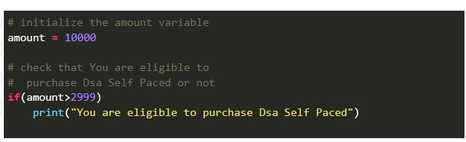

OUTPUT:
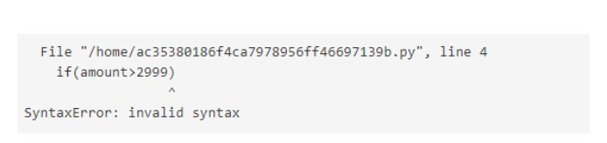
TYPE ERROR:-

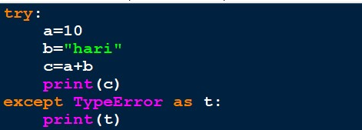
OUTPUT:
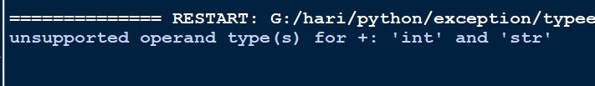

NAME ERROR:-
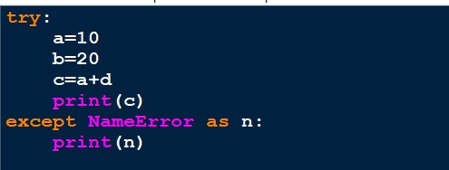
OUTPUT:-
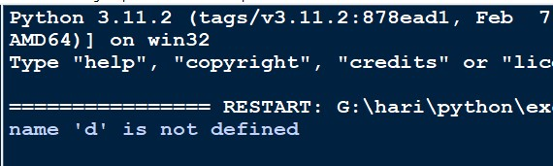

INDEX ERROR:-
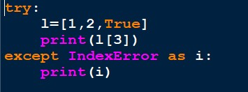

OUTPUT:-

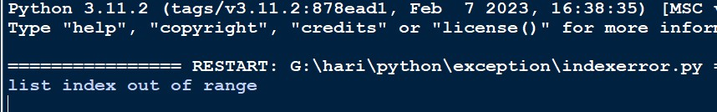

KEY ERROR:-
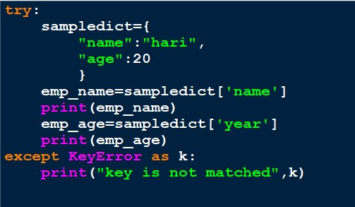
OUTPUT:-
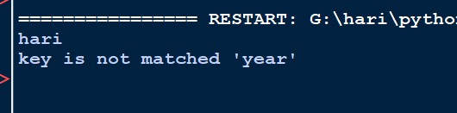

VALUE ERROR:-
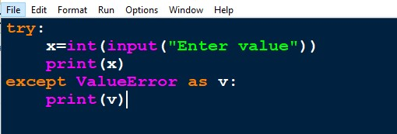

OUTPUT:-

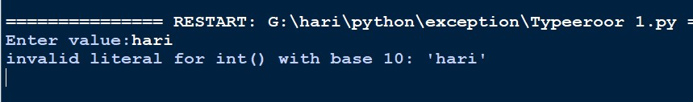

ATTRIBUTE ERROR:-

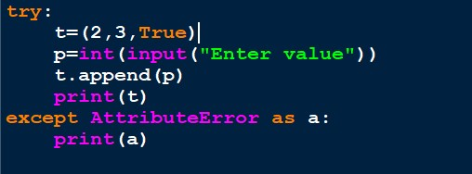
OUTPUT:-
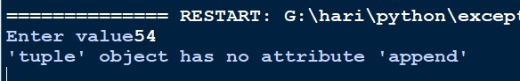

IO ERROR:-
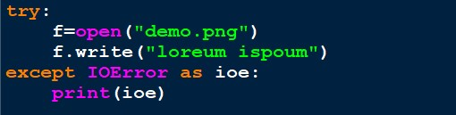

OUTPUT:-
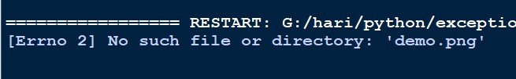

ZERO DIVISION ERROR:-
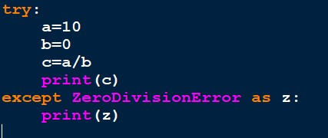

OUTPUT:-

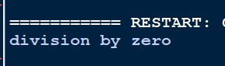

IMPORT ERROR:-
The ModuleNotFoundError exception is raised when a module is not found during the import process. It is a subclass of the more general ImportError exception. This means that
ModuleNotFoundError inherits the behavior and properties of ImportError but provides more specific information regarding the module that could not be found.
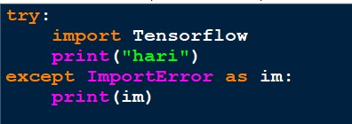
OUTPUT:-

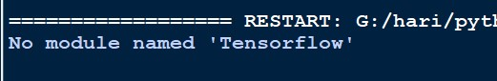

Tryelse:-
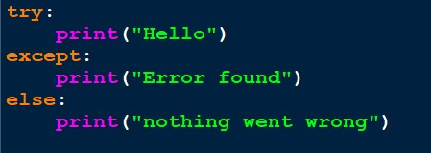

OUTPUT:-

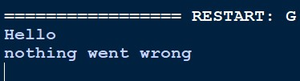
Finally:-
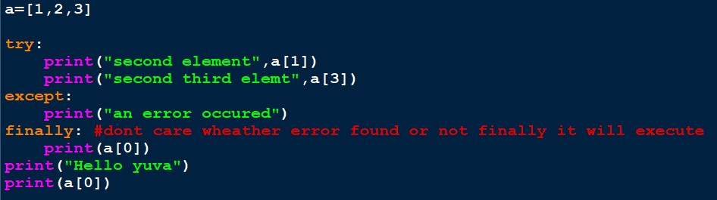
OUTPUT:-

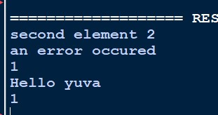

Custome Exception:-
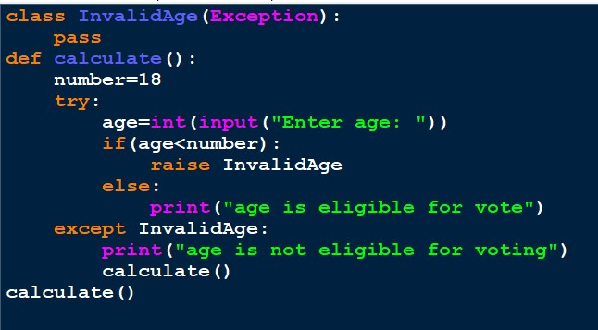

OUTPUT:-

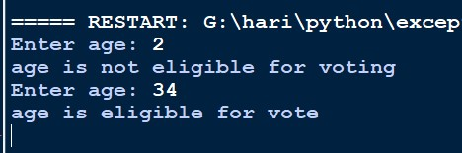

Custom Exception:-

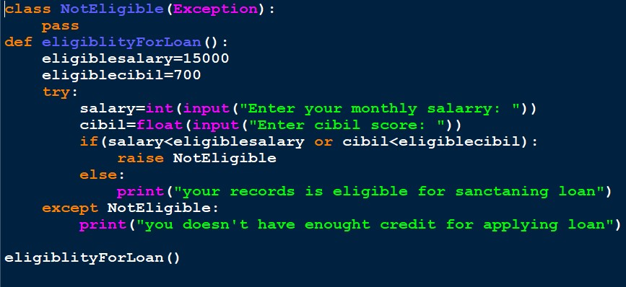
OUTPUT:-

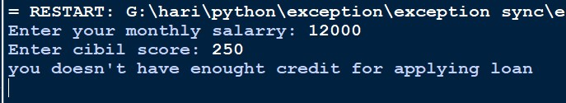

Introduction Of Lambda function
Python Lambda Functions are anonymous functions, meaning functions without a name. Normally, we use the 'def' keyword to define a function, but for anonymous functions, we use the 'lambda' keyword.
Characteristics:
- This function can have any number of arguments but only one expression, which is evaluated and returned.

Program 1
str1 = "yuva Sakthi academy"
upper = lambda str1: str1.upper()
print(upper(str1))

Program 2
sum = lambda a,b: a+b
x = int(input('Enter x: '))
y = int(input('Enter y: '))
z = sum(x,y)
print('sum =', z)

Questions
- 1. Area of triangle → A = √(s*(s−a)*(s−b)*(s−c))
- 2. Perimeter of triangle → P = a + b + c
- 3. Area of Equilateral triangle → A = a²

Program 3
big = lambda a,b: print('a is bigger') if(a>b) else print('b is bigger')
a = int(input('Enter a'))
b = int(input('Enter b'))
big(a,b)

a) Biggest of Three Numbers
big = lambda a,b,c: print('a is bigger') if(a>b and a>c) else print('b is bigger') if(b>c) else print('c is bigger')
a=int(input('Enter a'))
b=int(input('Enter b'))
c=int(input('Enter c'))
big(a,b,c)

b) Smallest of Three Numbers
big = lambda a,b,c: print('a is smaller') if(a<b and a<c) else print('b is smaller') if(b<c) else print('c is smaller')
a=int(input('Enter a'))
b=int(input('Enter b'))
c=int(input('Enter c'))
big(a,b,c)

c) Biggest of Four Numbers
big=lambda a,b,c,d: print('a is bigger') if(a>b and a>c and a>d) else print('b is bigger') if(b>c and b>d) else print('c is bigger') if(c>d) else print('d is bigger')
a=int(input('Enter value'))
b=int(input('Enter value'))
c=int(input('Enter value'))
d=int(input('Enter value'))
big(a,b,c,d)

d) Smallest of Four Numbers
big=lambda a,b,c,d: print('a is smaller') if(a<b and a<c and a<d) else print('b is smaller') if(b<c and b<d) else print('c is smaller') if(c<d) else print('d is smaller')
a=int(input('Enter value'))
b=int(input('Enter value'))
c=int(input('Enter value'))
d=int(input('Enter value'))
big(a,b,c,d)

e) Students Marklist
grade=lambda tam,eng,math,phy,che,ave: print('fail') if(tam<35 or eng<35 or math<35 or phy<35 or che<35) else print('Grade is O') if(ave>90) else print('Grade is A') if(ave>75) else print('Grade is B') if(ave>50) else print('fail')
name=input('Enter name: ')
roll_no=input('Enter Roll No: ')
year=int(input('Enter Year'))
mob_no=input('Enter mobile no: ')
tam=float(input('Enter Tamil'))
eng=float(input('Enter English'))
math=float(input('Enter Maths'))
phy=float(input('Enter Physics'))
che=float(input('Enter Chemistry'))
tot=tam+eng+math+phy+che
ave=tot/5
print('Name=', name)
print('Roll No: ', roll_no)
print('Year: ', year)
print('Total: ', tot)
grade(tam,eng,math,phy,che,ave)

f) Sales Commission
Sales | Commission
Up to 10000 | 0%
10000 to 20000 | 5%
20000 to 50000 | 10%
50000 to 100000 | 15%
100000 and above | 20% + 500 bonus
com=lambda sale:print((sale*0)//100) if(sale<10000) else print((sale*5)//100) if(sale<20000) else print((sale*10)//100) if(sale<50000) else print((sale*15)//100) if(sale<100000) else print((sale*20)//100+500) if(sale>100000) else print('invalid')
sale=int(input('Enter sales'))
com(sale)

g) Tax Calculation
Purchase Amount | Tax %
Up to 10000 | 0%
10000 to 20000 | 10%
20000 and above | 20%
tax=lambda x: x*0/100 if(x<10000) else ((x-10000)*10/100)if(x<20000) else ((x-20000)*20//100+(10000*10//100)) if(x>=20000) else 'invalid'
x=int(input('Enter tax'))
z=tax(x)
print('Tax: ',z)

h) Electricity Bill
Units | Charge per Unit
Up to 199 | @1.20
200 to 400 | @1.50
400 to 600 | @1.80
600 and above | @2.00
eb=lambda unit:(unit*1.2) if(unit<200) else ((unit-199)*1.5+(199*1.2)) if(unit<400) else ((unit-399)*1.8+(199*1.2)+(200*1.5)) if(unit<500) else ((unit-599)*2+(199*1.2)+(200*1.5)+(200*1.8)) if(unit>599) else 'sorry'
unit=int(input('Enter unit'))
z=eb(unit)
if(z>400):
sur=(z*15//100)
z=sur+z
print(z)

Program 4
power = lambda x:[i**2 for i in x]
l=[2,4,6,8]
z=power(l)
print(z)

Map
The map() function applies a given function to all the items in an iterable (like list, tuple, etc.) and returns a map object (which can be converted to list, tuple, etc.).
- Syntax: map(function, iterable)
Example:
numbers = [1, 2, 3, 4, 5]
squares = list(map(lambda x: x**2, numbers))
print(squares) # Output: [1, 4, 9, 16, 25]
l=[1,2,3,4,5]
final=list(map(lambda l:l*3,l))
print(final)
animal=('Tiger','Lion','Monkey')
upp=tuple(map(lambda animal: animal.upper(),animal))
print(upp)

Filter
The filter() function constructs an iterator from elements of an iterable for which a function returns true. It is used to filter elements based on a condition.
- Syntax: filter(function, iterable)
Example:
numbers = [10, 15, 20, 25, 30]
evens = list(filter(lambda x: x%2==0, numbers))
print(evens) # Output: [10, 20, 30]

l=(5,56,3,2,76)
li=tuple(filter(lambda x: (x%2 == 0),l))
print(li)
age=(34,23,3)
adult=tuple(filter(lambda age: age>18,age))
print(adult)

Reduce
The reduce() function is defined in the functools module. It applies a rolling computation to sequential pairs of values in an iterable.
- Syntax: reduce(function, iterable)
Example:
from functools import reduce
numbers = [1, 2, 3, 4, 5]
product = reduce(lambda x, y: x*y, numbers)
print(product) # Output: 120

l=(5,56,3,2,76)
li=tuple(filter(lambda x: (x%2 == 0),l))
print(li)
age=(34,23,3)
adult=tuple(filter(lambda age: age>18,age))
print(adult)

Python Dates
📅 Working with Dates in Python
In Python, dates are not a data type of their own, but we can use the datetime module to work with dates as date objects.

✅ Example: Display the current date and time
import datetime

x = datetime.datetime.now()
print(x)
Output:
2023-09-29 13:30:30.915068
This output includes:
- Year
- Month
- Day
- Hour
- Minute
- Second
- Microsecond

🔍 Accessing Parts of the Date
You can extract specific information from the datetime object using its attributes and methods.
import datetime

x = datetime.datetime.now()

print(x.year) # Year
print(x.strftime("%A")) # Weekday name
Output:
2023
Friday

🧱 Creating Date Objects
You can create a specific date using the datetime() constructor.
import datetime

x = datetime.datetime(2020, 5, 17)

print(x)
Output:
2020-05-17 00:00:00
You can also pass optional time parameters:
- hour
- minute
- second
- microsecond
- timezone (tzone)
Default values for time = 0, tzone = None.

🎨 Formatting Dates with strftime()
The strftime() method formats datetime objects into readable strings.
import datetime

x = datetime.datetime(2018, 6, 1)

print(x.strftime("%B")) # Full month name

Output:
June
strftime() takes a format code as a parameter to return the string in the specified format.

Let me know if you'd like a full list of format codes (like %Y, %m, %d, etc.) or want to try some hands-on exercises!

DATABASE CONNECTION:-

The main purpose of this topic is to understand how to connect a Python program with a MySQL database and perform basic CRUD operations:
- C → Create (Insert data)
- R → Read (Select data)
- U → Update (Modify existing data)
- D → Delete (Remove records)
This helps us interact with databases directly from Python, which is essential for developing applications like:
- Employee Management Systems
- Student Management Systems
- Billing Applications
- Any software where data must be stored and retrieved.

Step 1: Install MySQL Connector
C:\Program Files\Python310\Scripts>pip install mysql-connector-python

Step 2: Database Connection File (conn.py)
import mysql.connector

mydb = mysql.connector.connect(
host="localhost",
user="root",
password="1234", # Change this to your MySQL root password
database="yuva" # Change this to your database name
)

mycursor = mydb.cursor()

Step 3: CRUD Operations File (crud.py)
import conn

# Establish connection
mydb = conn.get_connection()
mycursor = mydb.cursor()

# Ensure student table exists
def create_table():
try:
mycursor.execute("""
CREATE TABLE student (
rollno INT,
stname VARCHAR(50),

city VARCHAR(50)
)
""")
mydb.commit()
except Exception as e:
print("Error creating table:", e)

def insert():
try:
a = int(input("Enter rollno: "))
b = input("Enter name: ")
c = input("Enter city: ")
sql = "INSERT INTO student(rollno, stname, city) VALUES (%s, %s, %s)"
val = (a, b, c)
mycursor.execute(sql, val)
mydb.commit()
print(mycursor.rowcount, "record(s) inserted.")
except Exception as e:
print("Insert Error:", e)

def select():
try:
print("Displaying rollno, name, and city from student table:")
query = "SELECT rollno, stname, city FROM student"
mycursor.execute(query)
myresult = mycursor.fetchall()
if not myresult:
print("No records found.")
for row in myresult:
print(row)
except Exception as e:
print("Select Error:", e)

def update():
try:
rollno = int(input("Enter Roll No: "))
stname = input("Enter new Name: ")
inputdata = (stname, rollno)
statement = "UPDATE student SET stname=%s WHERE rollno=%s"
mycursor.execute(statement, inputdata)
mydb.commit()
if mycursor.rowcount > 0:
print("Record updated.")
else:
print("No record found with that rollno.")
except Exception as e:
print("Update Error:", e)

def delete():
try:
rollno = int(input("Enter Roll No to delete: "))
query = "DELETE FROM student WHERE rollno=%s"
mycursor.execute(query, (rollno,))
mydb.commit()
if mycursor.rowcount > 0:
print("Record deleted.")
else:
print("No record found with that rollno.")
except Exception as e:
print("Delete Error:", e)

# Main Program
create_table()

while True:
print("\n--- Student Management Menu ---")
print("1. Insert")
print("2. Select")
print("3. Update")
print("4. Delete")
print("5. Exit")

try:
choice = int(input("Enter choice (1-5): "))
if choice == 1:
insert()
elif choice == 2:
select()
elif choice == 3:
update()
elif choice == 4:
delete()
elif choice == 5:
print("Exiting program...")
break
else:
print("Invalid choice. Please try again.")
except ValueError:
print("Please enter a valid number (1-5).")

mydb.close()

